JavaScript Fundamentals - 1

Values and Datatypes

1,Create a javaScript file using javaScript comments ,list , all the data types of javaScript and specify example for each of them .

Ans : The following are the data types of the javaScript :

a.number

b.boolean

c.string

d.BigInt

e.undefined

f.null

g.symbol

h.object

/*

1 : number = 45

2 : string = "Shibaram Sathua"

3 : boolean = true or false

4 : BigInt = 12123n

5 : object = {name : "Shibaram Sathua" , age : 20}

6 : undefined : var name;

console.log(name)

7 : null : var name = null

console.log(name)

8 : symbol('Shibram Sathua')

*/

2 .Create an array of ten products that you have recently purchased recently fro any e commerce website.

Ans :

/*

const array = ["Mechanical Keyboard",

"Laptop",

"earphone",

"Laptop cover",

"Blutooth Speaker",

"Phone cover",

"new ssd",

"wirless Mouse",

"Extension Board",

"Power of subconsious mind"]

*/

3. Create an object of a student registry of 5 students whose key is the registration number and the value is the student name. Registration number starts from 1 and continues.

Ans:

/*

{

1 : "Mithun",

2 : "Alaka",

3 : "Anurag",

4 : "Prabir",

5 : "Shivam"

}

*/

Variable and typeof

1 .Specify an example for all the datatyps in javaScript ,store the varibale and verify the typrof value stored .

// 1 : number

let number = 34;

console.log(typeof number)

//number

// 2 : string

let personName = "SHibaram Sathua"

console.log(typeof personName)

// string

// 3 : boolean

let value = true;

console.log(typeof value)

// boolean

// 4 : BigInt

let bigNumber = 1234n;

let bigNumber2 = BigInt(21232)

console.log(typeof bigNumber)

console.log(typeof bigNumber2)

// bigint

// bigint

// 5 : object

const user = {

name : "Shibaram Sathua",

age : 23,

address : "Odisha"

}

console.log(typeof user)

// object

// 6 : undefined :

var userName;

console.log(typeof userName)

// undefined

// 7 : null :

var user1 = null

console.log(typeof user1)

// object

// 8 : Symbol

const symbol1 = Symbol('Shibram Sathua')

console.log(typeof symbol1)

// symbol

2. Create 2 valid variables and 2 invalid variables and print them onto the console. Comment the results and error message.

Ans :

// let number = 23;

// console.log(number)

//23

// let nameOfThePerson = "Shibarm Sathua"

// console.log(nameOfThePerson)

// Shibarm Sathua

// let 1name = "Harshit"

// console.log(1name)

//SyntaxError: Invalid or unexpected token

// let var = 123

// console.log(var)

//SyntaxError: Unexpected token 'var'

Operators

1. Write a program that prints the multiplication table in the textbook format of any number specified.

Ans :

let number = 7;

for(let i = 1 ; i <= 10 ; i++ )

{

console.log(`${number} * ${i} = ${number * i}`)

}

// 7 * 1 = 7

// 7 * 2 = 14

// 7 * 3 = 21

// 7 * 4 = 28

// 7 * 5 = 35

// 7 * 6 = 42

// 7 * 7 = 49

// 7 * 8 = 56

// 7 * 9 = 63

// 7 * 10 = 70

2. Write a program to perform all the arithmetic operations[except increment and decrement operators] of javascript of any two numbers stored in the variables num1 and num2. Also, print the results to the console.

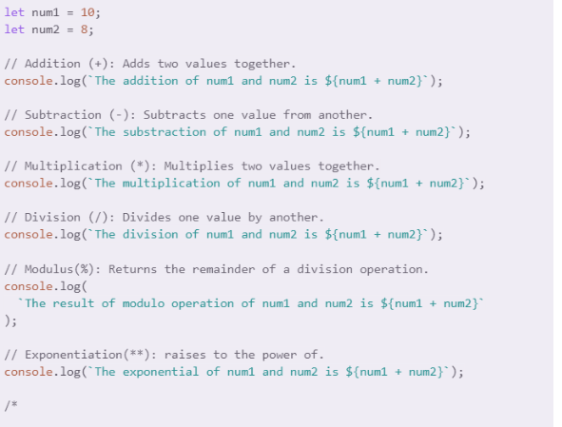

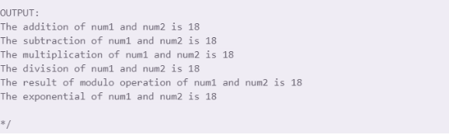

3. Write a program to find out the perimeter of a rectangle. Print the results to the console.

Ans:

let length = 34;

let breadth = 23;

const perimeterOfTriangle = 2 * (length + breadth)

console.log(perimeterOfTriangle)

//114

Ans:

3. Write a program to demonstrate the results of comparison operators. Note that both the truth and false

condition for each operator must be specified.

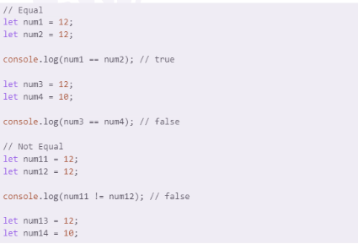

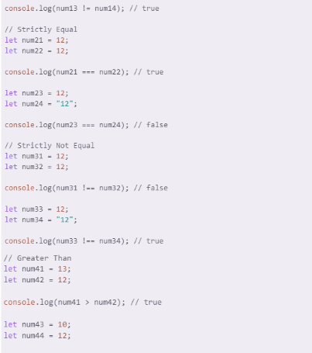

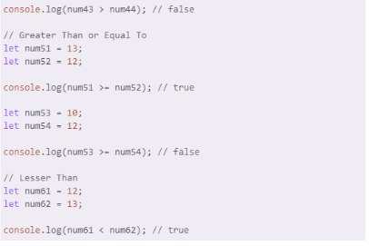

What are Conditions, If, If-else, if-else-if

1. Write a program of traffic control that accepts the traffic light displayed and prints the message. If the traffic light is red print the vehicles must stop .

Ans:

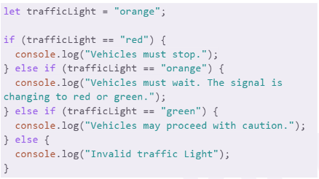

Ans:

2. Write a program to print the largest of 2 numbers.

Ans:

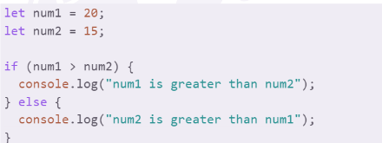

3. Write a program that takes a number as input and outputs "Fizz" if it is divisible by 3, "Buzz" if it is divisible

by 5, and "FizzBuzz" if it is divisible by both 3 and 5. Note that any number can be passed and not restricted to the numbers divisible by 3 or 5.

Ans:

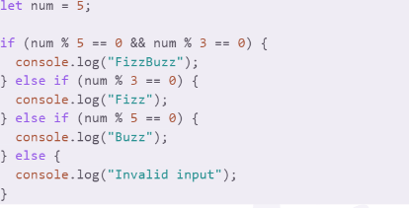

Switch Case

1. Write a program that takes in a day of the week (e.g., Monday, Tuesday, etc.) and outputs the number of days until the weekend .

Ans:

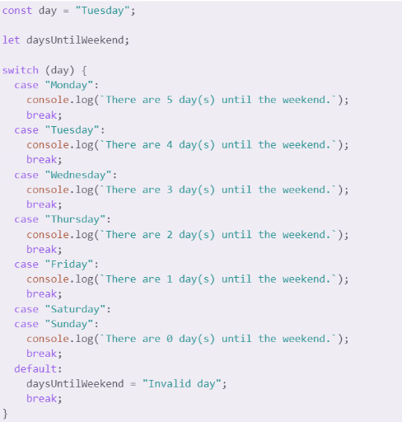

Ternary Conditions

1. Write a program that takes in a number and outputs whether it is positive, negative, or zero.

Ans:

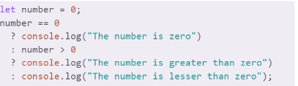

2. Create a program that takes in two numbers and prints the larger one.

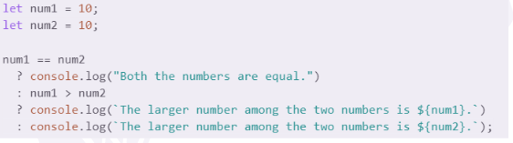

Loops

1. Write a program that generates the multiplication table in the textbook format for a given number.

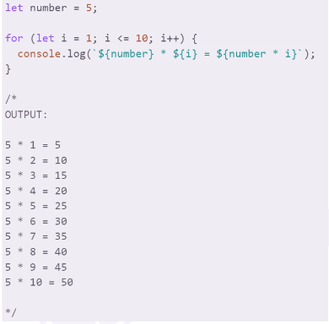

2. Write a program that prints all the positive even numbers till the number specified.

Ans:

